**DUA MIRANI**

**21SW084**

**LAB 08 TASKS**

1. **Write a java program based on filing. Perform Create, Read and Write operations on JSON file.**

package pckg.Lab8;

import java.io.FileReader;

import java.io.FileWriter;

import java.io.IOException;

import org.json.simple.JSONObject;

import org.json.simple.parser.JSONParser;

import org.json.simple.parser.ParseException;

public class lab8task1 {

public static void main( String[] args ) throws IOException, ParseException

{

JSONObject Student = new JSONObject();

Student.put("Name", "dua");

Student.put("Age", "19");

Student.put("Dept", "Software");

FileWriter file = new FileWriter("Student.json");

file.write(Student.toString());

file.close();

Object obj = new JSONParser().parse(new FileReader("Student.json"));

JSONObject read = (JSONObject) obj;

System.out.println((String) read.get("Name"));

System.out.println((String) read.get("Dept"));

}

}

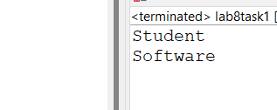

**2.Write a java program based on filing. Perform Create, Read and Write operations on text file using BufferedReader and BufferedWriter Classs**

package pckg.Lab8;

import java.util.Scanner;

import java.io.BufferedReader;

import java.io.BufferedWriter;

import java.io.FileReader;

import java.io.FileWriter;

import java.io.IOException;

public class lab8task2 {

public static void main(String[] args) {

Scanner sc = new Scanner(System.in);

System.out.println("Reading from first line");

try {

BufferedReader reader = new BufferedReader(new FileReader("output.txt"));

System.out.println(reader.readLine());

reader.close();

}

catch (IOException e) {

e.printStackTrace();

}

String Input=sc.next();

System.out.println("Writing to the line");

try {

BufferedWriter writer = new BufferedWriter(new FileWriter("output.txt"));

writer.append("\n"+Input);

writer.close();

System.out.println("Input has been written");

}

catch (IOException e) {

e.printStackTrace();

}

sc.close();

}

}

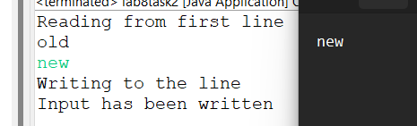

**3.Write a program that opens a file in write mode(use file modes), takes name and roll no from the students write it in the file and closes the file.**

**package** pckg.Lab8;

**import** java.io.File;

**import** java.io.FileNotFoundException;

**import** java.io.FileWriter;

**import** java.io.IOException;

**import** java.io.RandomAccessFile;

**import** java.util.Scanner;

**public** **class** lab8task3 {

**public** **static** **void** main(String[] args) **throws** IOException {

File file = **new** File("Write.txt");

Scanner sc = **new** Scanner(System.***in***);

System.***out***.println("Enter your name");

String name=sc.next();

System.***out***.println("Enter your rollno");

String rollno=sc.next();

**try** {

RandomAccessFile WriteFile = **new** RandomAccessFile(file, "rw");

WriteFile.write(name.getBytes());

WriteFile.write("\n".getBytes());

WriteFile.write(rollno.getBytes());

}

**catch** (FileNotFoundException e) {

e.printStackTrace();

}

}

}

